Name:

ID:

Submit here: <https://docs.google.com/forms/d/e/1FAIpQLSc8gOMOocFXV92i1N4S-e9Kozern_wWzfxpZzrSYAEeA7zCUw/viewform>

PART 1: (**60 MARKS**)

1. Consider the following:

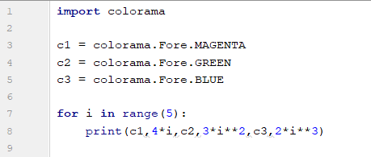

* Which color has the smallest value?

|  |  |
| --- | --- |
| magenta | green |
| blue | navy |
| black | white |

1. The following code generates the famous Collatz sequence. The sequence is started at any integer **n** and continued by dividing **n** by 2 if **n** is even, and multiply **n** by 3 and adding 1 if **n** is odd. A famous unsolved mystery in mathematics is whether or not there exists a value for n where the sequence will not reach 1.

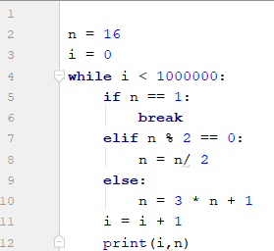

* What is the collatz sequence for n=20?

|  |  |
| --- | --- |
| 1,2,3,4,5,6,7 | 8,4,2,1 |
| 20,60,30,20,15,46,23,70,35,106,53,160,80,40,20,10,5,16,8,4,2,1 | 10,5,16,8,4,2,1 |
| 20,61,30,15,7,3,2,1 | 20,10,5,16,8,4,2,1 |
| 0,1,2,3,4,5,6,7 | 20,10,5,2,1 |

* How long is the collatz sequence for n = 33?

|  |  |
| --- | --- |
| 26 | 33 |
| 25 | 27 |
| 1 | 25 |
| 100 | 6 |

* Which of the following has the longest collatz sequence?

|  |  |
| --- | --- |
| 19 | 20 |
| 21 | 22 |
| 23 | 24 |
| 25 | 26 |
| 27 | 28 |
| 29 |  |

Part 2: (**5 MARKS**)

[Lists: Part 2](https://runestone.academy/runestone/books/published/thinkcspy/Lists/intro-Lists.html)

1. The easiest way to clone a list involves using what operator? (10.12)
2. Evaluate the following: (10.12)

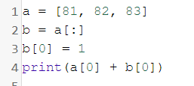

1. Evaluate the following: (10.13)

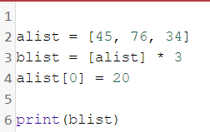

1. Evaluate the following: (10.13)

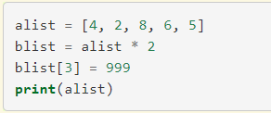

1. What are the differences between mutator, hybrid, and return results for list methods? (10.14)
2. Evaluate the following: (10.14)

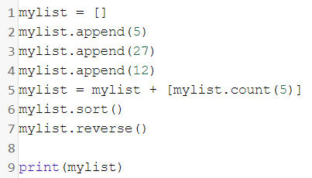

1. Evaluate the following: (10.14)

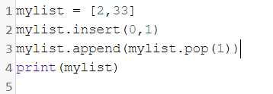

1. What position in a list is an element added if the append operation was used? (10.16)
2. What happens to the original list when append is used? What about when concatenation occurs? (10.16)
3. Consider the following: (10.17)

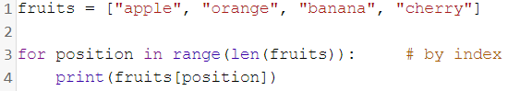

* What position is banana?
* What is fruits[3]?

PART 3: (**35 MARKS**)

1. Create a program that makes an *n* by *m* dimensional rectangle. Where *n* and *m* are random integers between 2 and 10.

Example:

n = 2

m = 2

**

**

n = 4

m = 3

****

****

****